**Initial Artifact Description**

**Justin Byrd**

**justin.byrd@snhu.edu**

**CS-499-H7089 Computer Science Capstone**

**Professor Brooke Goggin**

**12/10/2023**

# Initial Artifact:

The artifact central to my enhancements is the “RGB LED Cube Control Software”, a project initiated during my Electrical Engineering Technology Associate degree program’s capstone in 2015. Initially, I constructed a 4x4x4 LED Cube with RGB LEDs, shown below, integrating it with an FPGA development board and crafting custom firmware to manipulate the 52 control lines governing the 64 LEDs.

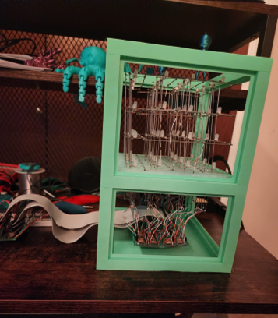

In a recent pursuit of rekindling my enthusiasm for the project, I designed additional circuitry to interface my RGB LED Cube Control Software with an Arduino Uno, facilitating control over the RGB LEDs. Prior to the start of this course, I had developed a simple functional user interface (UI), shown below, establishing communication with the Arduino Uno through a COM Port. This initial UI empowered me to illuminate one color of one LED based on user-defined color, X, Y, and Z values.

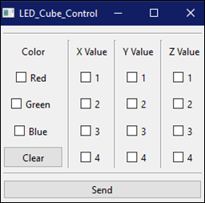

Having accomplished the hardware integration and circuitry enhancements, the focus of my Computer Science Capstone project pivots decisively to the evolution of the RGB LED Cube Control Software. With the foundational hardware components in place and the initial user interface demonstrating functional control over individual LEDs, my aim is to delve into advanced features and optimizations within the software realm. This shift marks the latest chapter in the ongoing development of a project that seamlessly marries my technical skills in both hardware and software domains.